**PASSWORD STRENGHT CHECKER**

Description

This reposition contain my practical work on password strength checker application that evaluates the strength of passwords entered by users.

Environment Used

* Visual Studio Code

Language Used

* HTML
* CSS
* JavaScript

Explanation

1. Criteria Checks:

* Length Criteria: Checks if the password is at least 8 characters long.
* Lowercase Criteria: Checks if the password contains at least one lowercase letter.
* Uppercase Criteria: Checks if the password contains at least one uppercase letter.
* Digit Criteria: Checks if the password contains at least one digit.
* Special Character Criteria: Checks if the password contains at least one special character unique character criteria: Ensures a good mix of unique characters

PASSWORD STRENGHT CHECKER INTERFACE

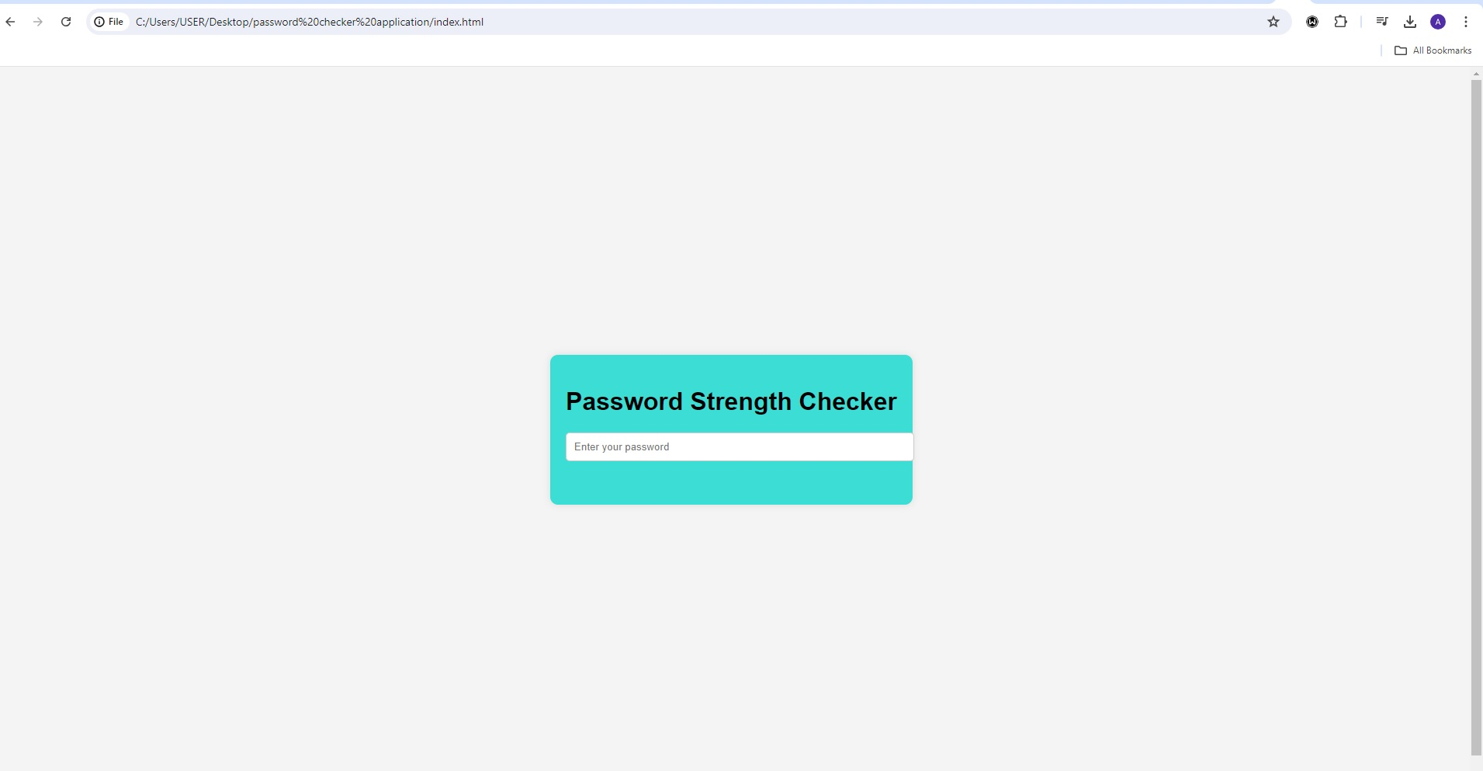

HTML CODE

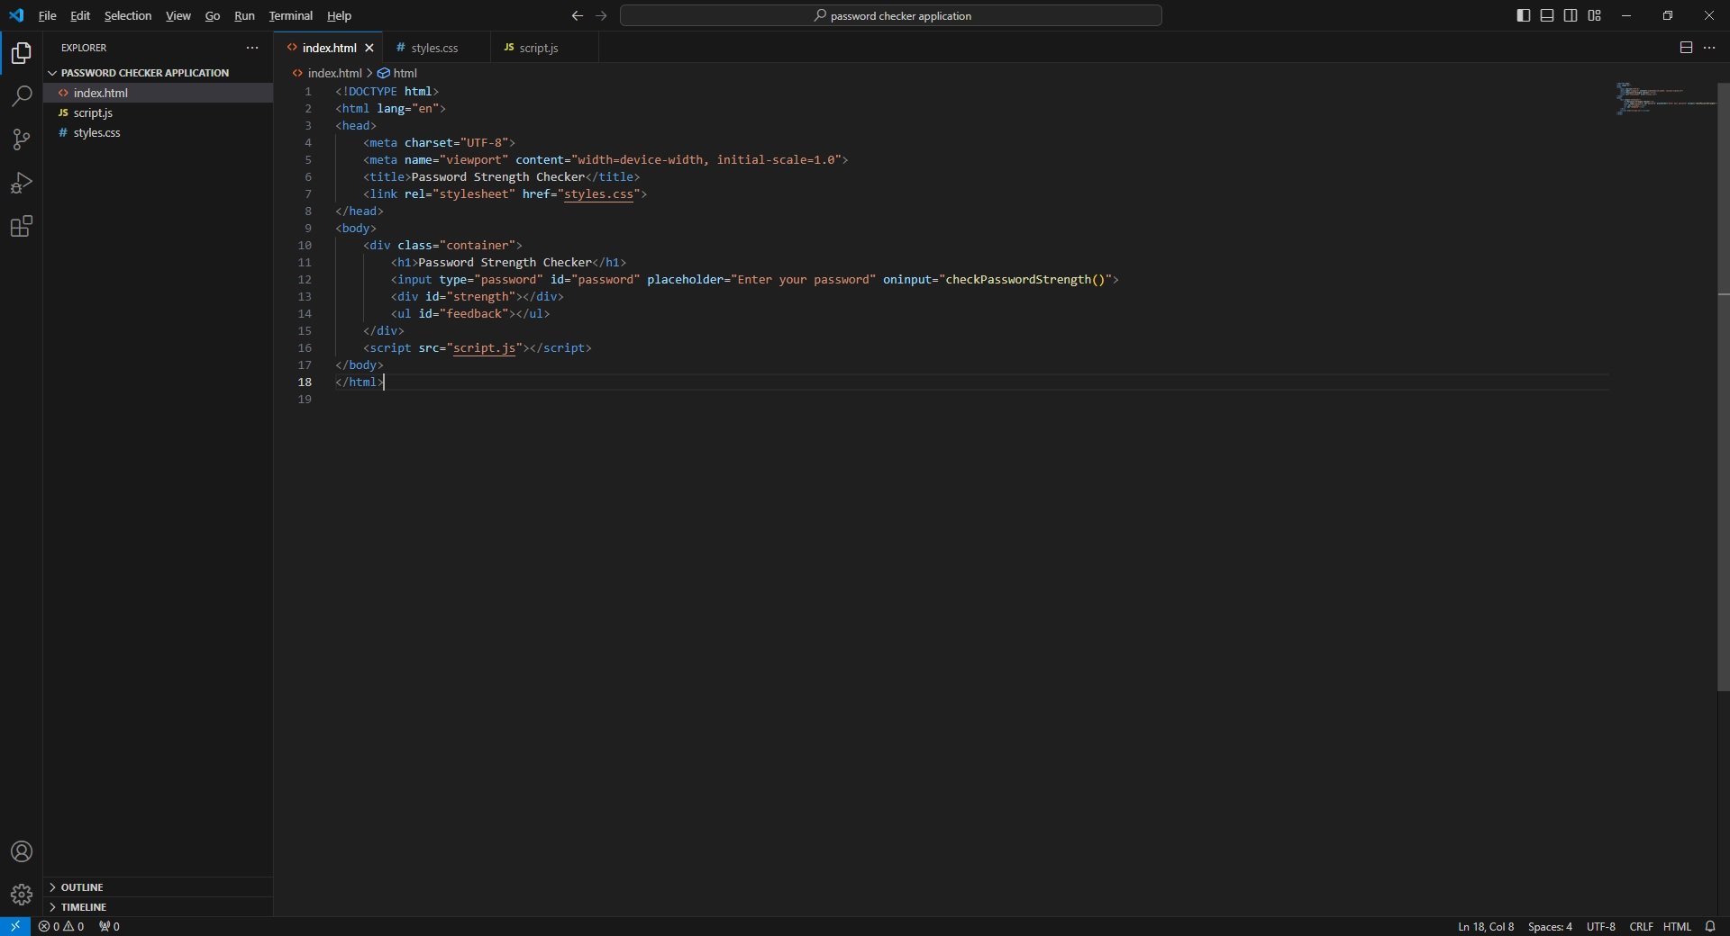

CSS CODE

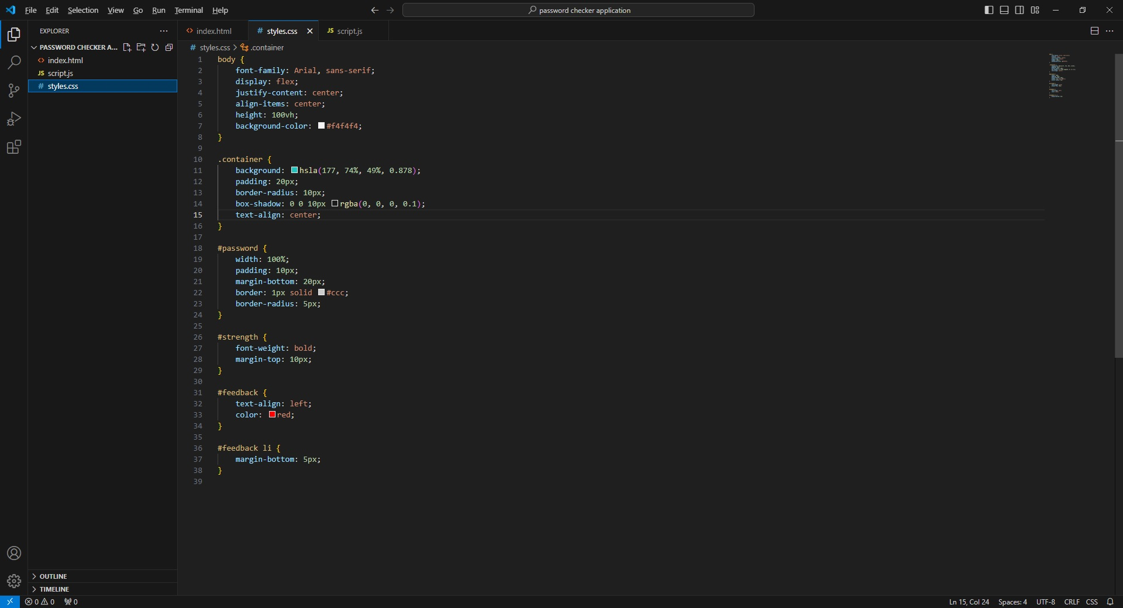

JAVASCRIPT

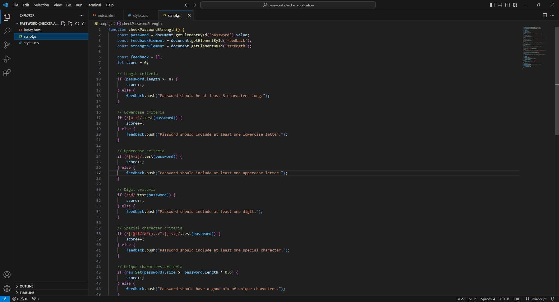

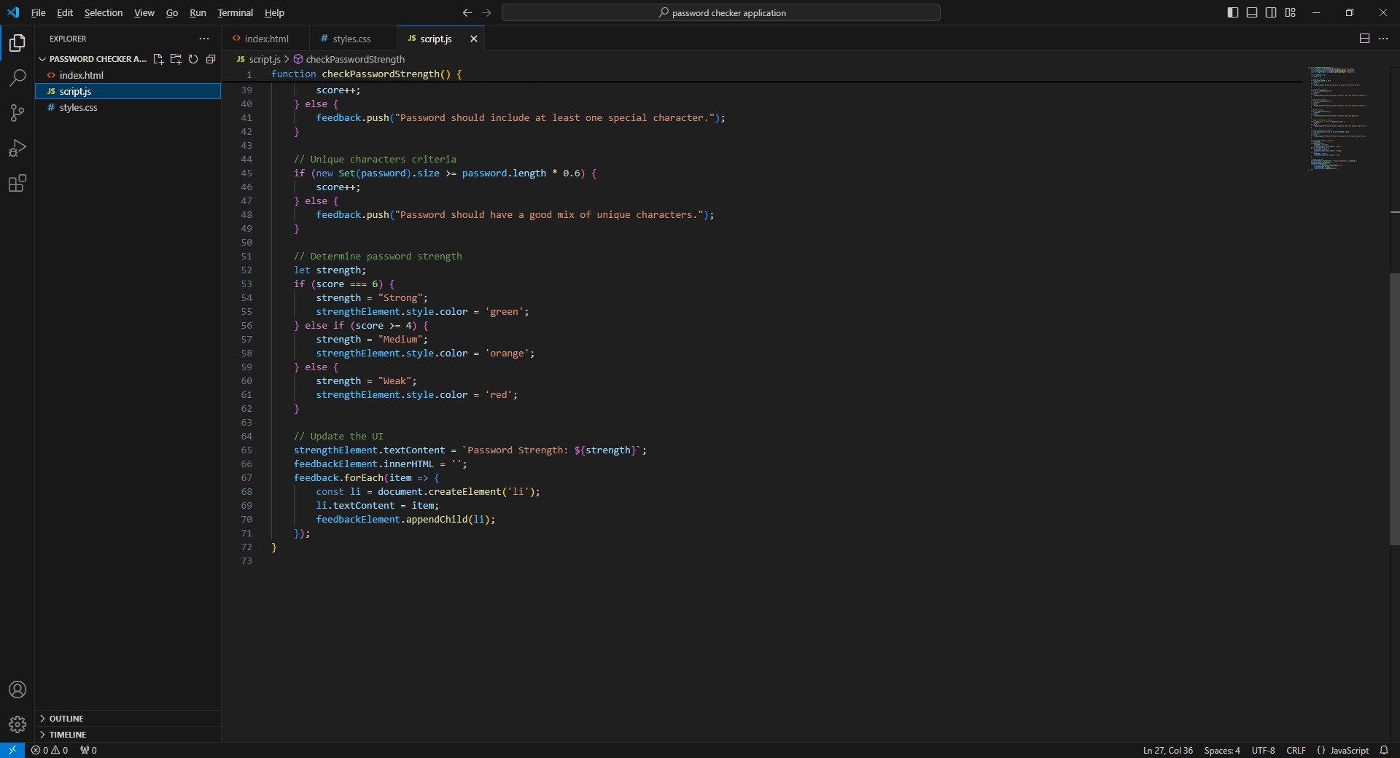

1. Strength Calculation:

* The strength score is calculated by summing up the number of criteria met by the password.

1. Feedback:

* Feedback is generated based on which criteria are not met.

1. Strength Determination:

* A password is considered "Strong" if all criteria are met, "Medium" if most criteria are met, and "Weak" if fewer criteria are met. The image below shows the result.

PASSWORD STRENGHT: STRONG

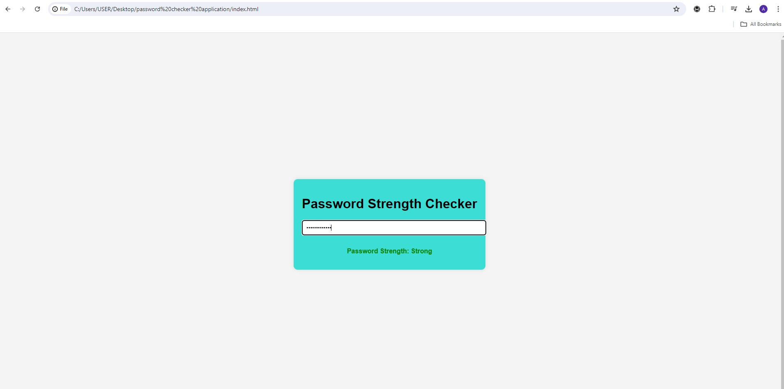

PASSWORD STRENGHT: MEDIUM

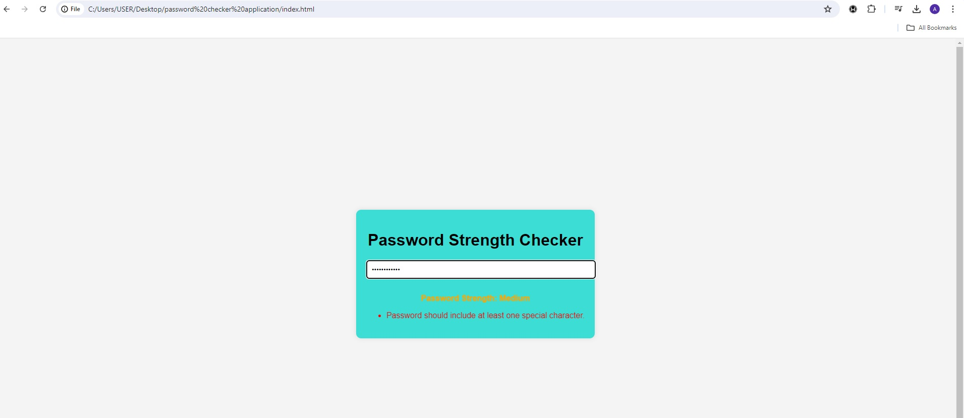

PASSWORD STRENGHT: WEAK

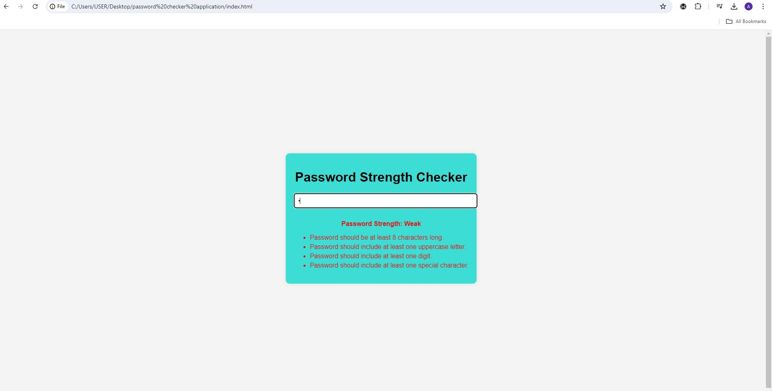

USAGE

* Run the script.
* Input the password when prompted
* Receive feedback on the strength of the password and suggestions for improvement.